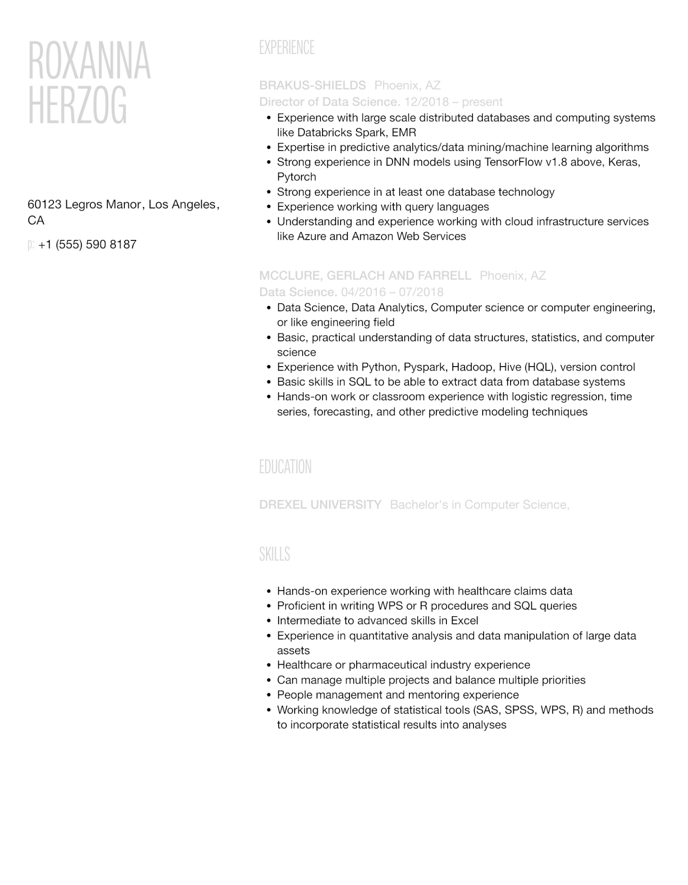
ROXANNA HERZOG
60123 Legros Manor, Los Angeles, CA
p: +1 (555) 590 8187
EXPERIENCE
BRAKUS-SHIELDS Phoenix, AZ
Director of Data Science. 12/2018 - present
• Experience with large scale distributed databases and computing systems like Databricks Spark, EMR
•
Expertise in predictive analytics/data mining/machine learning algorithms
• Strong experience in DNN models using TensorFlow v1.8 above, Keras, Pytorch
•
•
·
Strong experience in at least one database technology
Experience working with query languages
Understanding and experience working with cloud infrastructure services like Azure and Amazon Web Services
MCCLURE, GERLACH AND FARRELL Phoenix, AZ
Data Science. 04/2016 - 07/2018
• Data Science, Data Analytics, Computer science or computer engineering, or like engineering field
•
•
Basic, practical understanding of data structures, statistics, and computer science
Experience with Python, Pyspark, Hadoop, Hive (HQL), version control • Basic skills in SQL to be able to extract data from database systems
• Hands-on work or classroom experience with logistic regression, time series, forecasting, and other predictive modeling techniques
EDUCATION
DREXEL UNIVERSITY Bachelor's in Computer Science,
SKILLS
• Hands-on experience working with healthcare claims data
• Proficient in writing WPS or R procedures and SQL queries
• Intermediate to advanced skills in Excel
·
Experience in quantitative analysis and data manipulation of large data assets
• Healthcare or pharmaceutical industry experience
•
Can manage multiple projects and balance multiple priorities
•
People management and mentoring experience
·
Working knowledge of statistical tools (SAS, SPSS, WPS, R) and methods to incorporate statistical results into analyses

